CPIT – 250 Lab Work

ATM System Use Case Diagrams

|  |  |
| --- | --- |
| Ali Zaid Hamidaddin | **2137162** |
| Abdulaziz Khalifah | **2135939** |
| Mohammed Sonbul | **2138010** |

Department of Information Technology

Faculty of Computing and Information Technology (FCIT)

King Abdulaziz University

# Problem Description:

With the increase in bank accounts being opened, we face an overcrowding issue. Considering the current number of branches and, furthermore, the limited capacity that each branch can hold, the number of people that want to withdraw money from their accounts at any given time may far outnumber the capacity of these branches. Even if the branches are capable of serving hundreds of customers without any issues, the fact that there are only a handful of branches in each city means that people who live far away from these branches must commute to perform a trivial transaction. Another simple and very common transaction that customers tend to need is transferring money from one account to another. And in fact, the most simple and important thing that a customer needs access to is checking their balance. And with bank’s work hours being relatively short, it is even more likely to be crowded at the bank’s branches. Opening more branches is not cost-effective as it requires building, hiring employees, and other factors.

**Problem 1:** Branches cannot provide enough capacity to serve the customers.

**Problem 2:**  Small number of branches make it so living far means having to commute.

**Problem 3:** Any small transaction (withdrawal of money, transferring, checking balance, etc.) requires a visit to the bank

**Problem 4:** Bank’s work hours are limited and short.

**Problem 5:** Opening more branches is unnecessary, inefficient, and cost-effective.

# Problem Solution:

As previously mentioned, all of these problems can be solved if the bank opens more branches. As we know, this solution is not at all optimal from the point of view of the bank. And this is where the idea of the automated teller machine came into consideration. Instead of building new branches, which is expensive, we will open ATMs that perform many of the daily operations or transactions that customers need for little cost. As the name suggests, there are no employees to operate the ATM; instead, each customer can choose from a specific set of operations to perform. Opening these ATMs all over our cities will make it so that everyone has quick access to their bank accounts. Since these ATMs do not need any constant supervision, they can stay open 24/7 to serve any customers, needing only periodic maintenance and dispensable resources such as paper bills and receipt paper.

1. Do you live far away from a bank branch?

|  |  |  |  |  |
| --- | --- | --- | --- | --- |
| 1 | 2 | 3 | 4 | 5 |
| Strongly Disagree | Somewhat Disagree | Neutral/ Not Applicable | Somewhat Agree | Strongly Agree |

1. Do you withdraw money from your account often?

|  |  |  |  |  |
| --- | --- | --- | --- | --- |
| 1 | 2 | 3 | 4 | 5 |
| Strongly Disagree | Somewhat Disagree | Neutral/ Not Applicable | Somewhat Agree | Strongly Agree |

1. Are checking your balance, transferring money, or withdrawing money important and common transactions for you?

|  |  |  |  |  |
| --- | --- | --- | --- | --- |
| 1 | 2 | 3 | 4 | 5 |
| Strongly Disagree | Somewhat Disagree | Neutral/ Not Applicable | Somewhat Agree | Strongly Agree |

1. Does the process of transferring your money take a long time?

|  |  |  |  |  |
| --- | --- | --- | --- | --- |
| 1 | 2 | 3 | 4 | 5 |
| Strongly Disagree | Somewhat Disagree | Neutral/ Not Applicable | Somewhat Agree | Strongly Agree |

1. Do you visit a bank often to use its services?

|  |  |  |  |  |
| --- | --- | --- | --- | --- |
| 1 | 2 | 3 | 4 | 5 |
| Strongly Disagree | Somewhat Disagree | Neutral/ Not Applicable | Somewhat Agree | Strongly Agree |

1. Does crowding inside the bank bother you?

|  |  |  |  |  |
| --- | --- | --- | --- | --- |
| 1 | 2 | 3 | 4 | 5 |
| Strongly Disagree | Somewhat Disagree | Neutral/ Not Applicable | Somewhat Agree | Strongly Agree |

1. 1 being slow and 5 being fast, how would you rate the speed and accuracy of human tellers?

|  |  |  |  |  |
| --- | --- | --- | --- | --- |
| 1 | 2 | 3 | 4 | 5 |
| Strongly Disagree | Somewhat Disagree | Neutral/ Not Applicable | Somewhat Agree | Strongly Agree |

1. Do you generally face problems with staff?

|  |  |  |  |  |
| --- | --- | --- | --- | --- |
| 1 | 2 | 3 | 4 | 5 |
| Strongly Disagree | Somewhat Disagree | Neutral/ Not Applicable | Somewhat Agree | Strongly Agree |

1. Do you think the service could be faster?

|  |  |  |  |  |
| --- | --- | --- | --- | --- |
| 1 | 2 | 3 | 4 | 5 |
| Strongly Disagree | Somewhat Disagree | Neutral/ Not Applicable | Somewhat Agree | Strongly Agree |

10. Do you often need the bank outside of its work hours?

|  |  |  |  |  |
| --- | --- | --- | --- | --- |
| 1 | 2 | 3 | 4 | 5 |
| Strongly Disagree | Somewhat Disagree | Neutral/ Not Applicable | Somewhat Agree | Strongly Agree |

11. Are the bank working hours generally convenient for you?

|  |  |  |  |  |
| --- | --- | --- | --- | --- |
| 1 | 2 | 3 | 4 | 5 |
| Strongly Disagree | Somewhat Disagree | Neutral/ Not Applicable | Somewhat Agree | Strongly Agree |

12. (Directed to Banks); How often can you fulfill customers request?

|  |  |  |  |  |
| --- | --- | --- | --- | --- |
| 1 | 2 | 3 | 4 | 5 |
| Strongly Disagree | Somewhat Disagree | Neutral/ Not Applicable | Somewhat Agree | Strongly Agree |

13. (Directed to Banks); Can you keep up with the increase in new accounts being opened?

|  |  |  |  |  |
| --- | --- | --- | --- | --- |
| 1 | 2 | 3 | 4 | 5 |
| Strongly Disagree | Somewhat Disagree | Neutral/ Not Applicable | Somewhat Agree | Strongly Agree |

# Context Diagram:

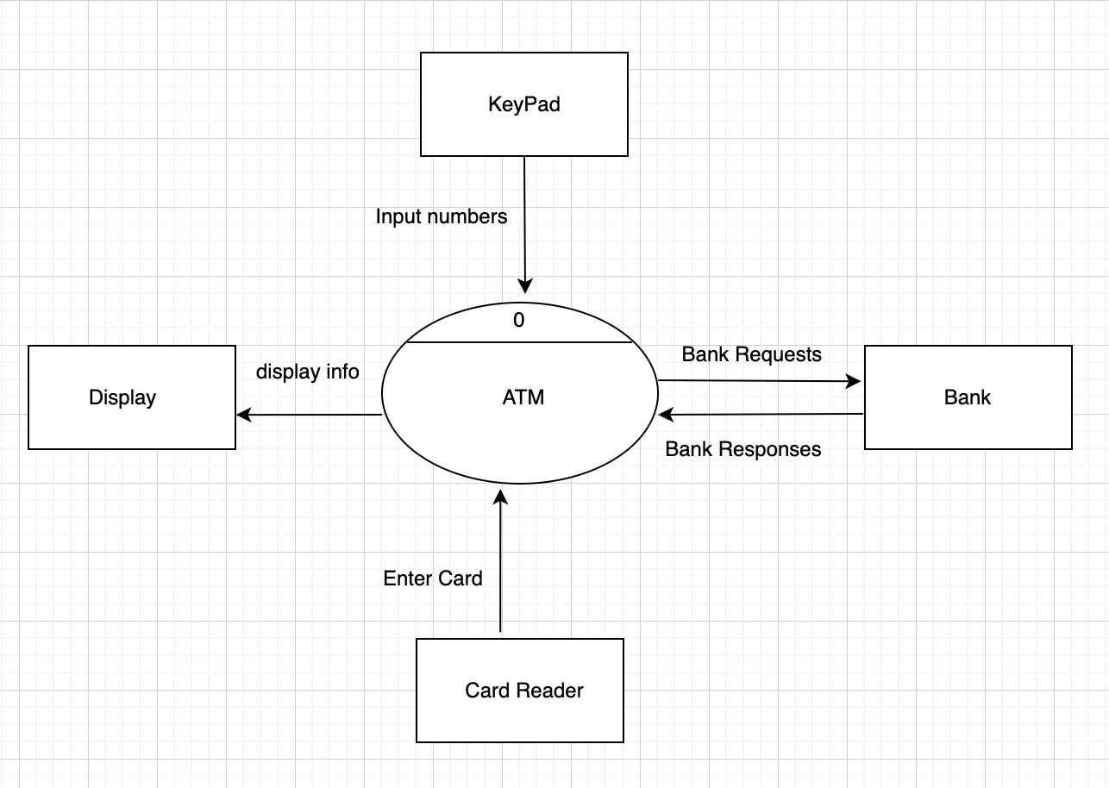

# Level-0 Diagram:

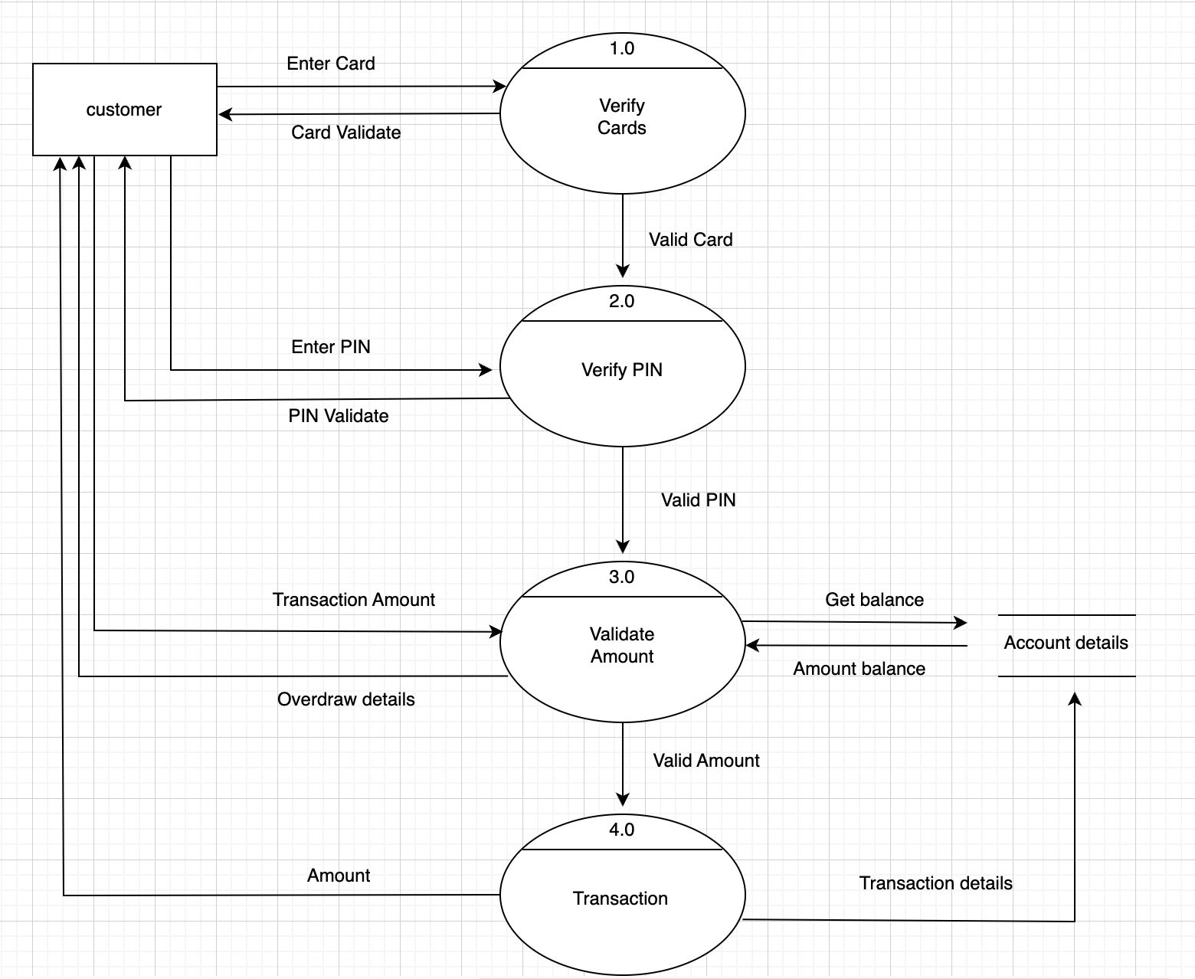

ATM System

**Use-case name:** ATM System

**Actors:** ATM operator, Customer

**Description:** A customer must enter a valid card and his correct PIN to be able to use an ATM. In the below figure, “Validate User” refers to the validation of the card, PIN, and any relevant details about the customer.

**Successful completion:** A customer will be able to access transactions for his own account.

**Alternative:** none

**Pre-condition:** A customer already has a created account.

**Post-condition:** Customer must have entered valid information.

**Assumption:** Customer will print a receipt for his transaction.

# Use Case Diagram:

*Note: As mentioned above, validate user will check valid card, PIN, etc.

# Class Diagram:

# Sequence Diagram:

# Activity Diagram:

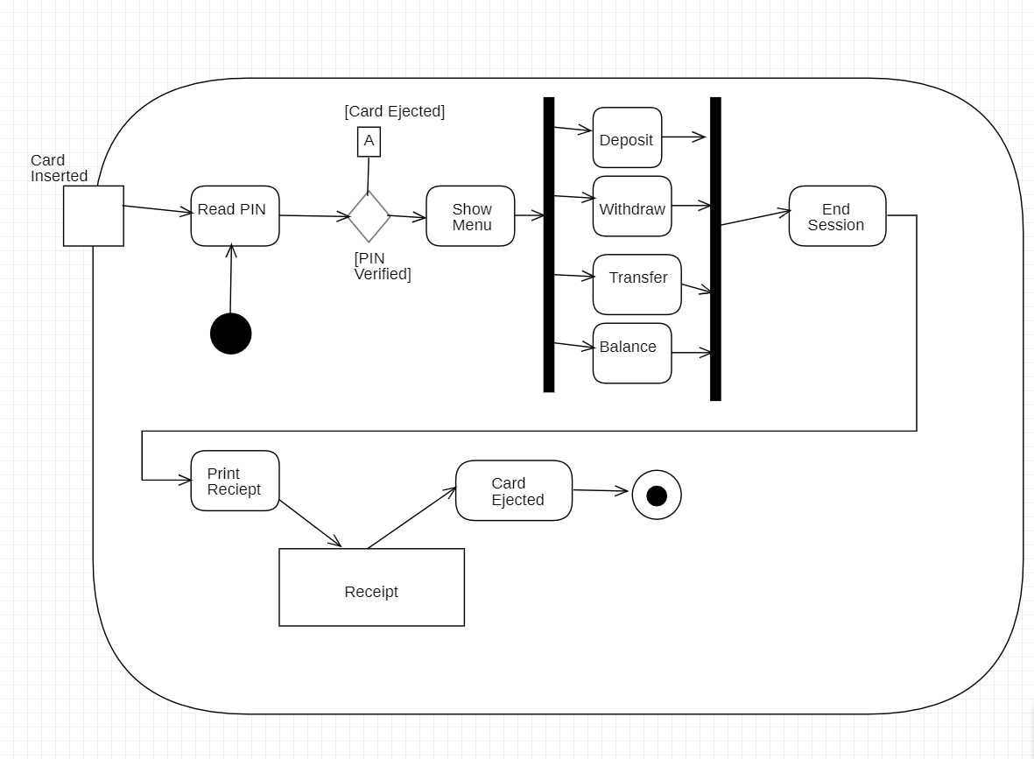

# Swimlane Diagram:

# State Diagram:

